**GENERAL HUMAN BIOLOGY – YEAR 11**

**TASK 10 – ALCOHOL & SMOKING DURING PREGNANCY**

**EXTENDED RESPONSE**

**MARKING KEY**

Research

* + Excellent A grade presentation = 4 marks
  + Detailed B grade = 3 marks
  + Adequate C grade = 2 marks
  + Limited D grade = 1 mark

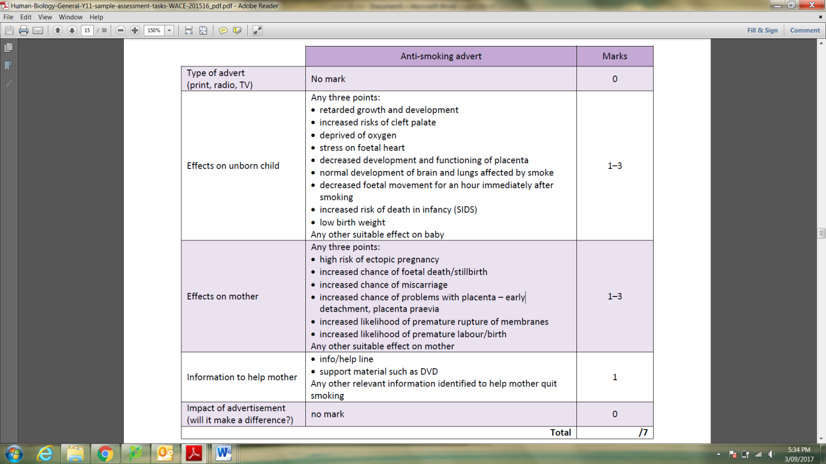Table – 11 marks

